**RESULT AND DESCRIPTION**

Our website “DigiFarm” is compatible with latest versions of browsers such as Google Chrome, Microsoft Edge, Mozilla Firefox etc. The Front-end of our website is designed using HTML 5, CSS 3 and JavaScript whereas for the Back-end we have used Django 3.2.5 (a Python back-end framework). On the top left corner of the Homepage (figure 1), you will find the logo of our website. The logo has two central elements: a hand along with the water. The water is representative of rivers and oceans that forms the backbone of the irrigation system in Indian agriculture. The hand that is holding a plant represents the farmers who grow the crops. Since India is an agrarian economy, not only is the population dependent on the farmers for food, but the national economy is also dependent on the yield from the primary sector. The website is designed to equip the farmers with digitized farming so that they can make the most out of their crops. With the aid of this website, they can receive precise information about which crops would be most suitable for their land. This analysis would be based on the:

1. region's weather conditions, pH of the soil, rainfall pattern and soil composition (nitrogen, phosphorus and potassium)
2. Location and current season

The Navigation bar on the homepage as shown in figure 1 has different icons for various purposes such as Home, ChatBot, Prediction, and Weather and News. Additionally, there are two icons: one to get the detailed tutorial on how to use the website for farmers and another for predicting the most suited crop(s).

The Scroll button at the bottom right corner will directly take you to the top of the webpage. The bottom of the page includes contact details for further assistance, complaints and feedback. Besides, the GitHub link provided at the bottom panel delineates the entire mechanism of the website.

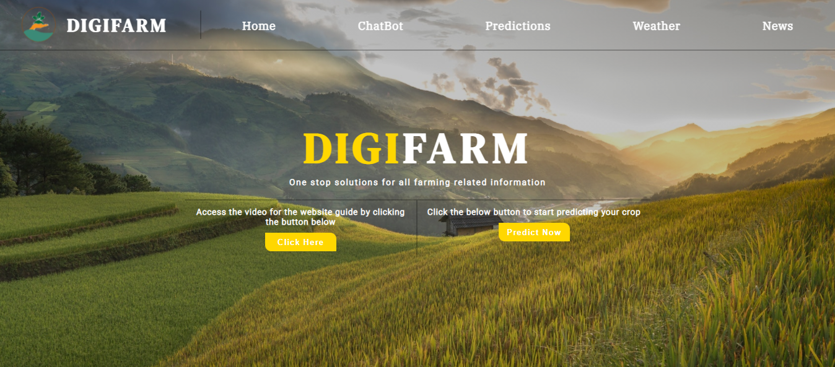

*Figure 1:Home Page*

The details on the different sections of the website are follows:-

1. **ChatBot Section**:- Our ChatBot as shown in figure 2 is an artificial intelligence bot which we have named “AgriBot” that is made using the IBM chatbot services (a part of IBM Cloud services). Users can make use of our chatbot to get their queries clarified. It is primarily used to serve three purposes: (a) an option directing the users to guide the website (b) crop prediction (c) link to the Google Form for further queries.

After clicking the chatbot icon, users will be redirected to a new window, where the ChatBot will greet them and provide the above mentioned three options (refer figure 2). These will function one at a time.

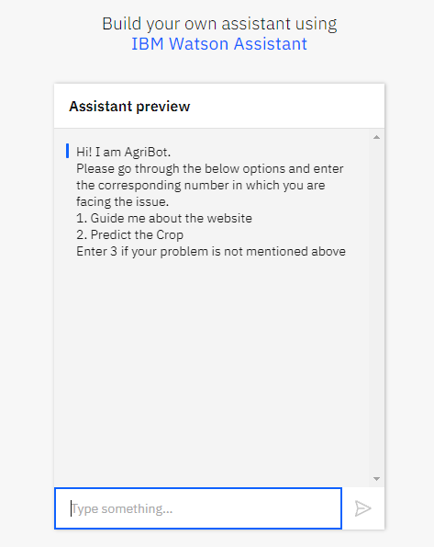

*Figure 2: ChatBot Page*

**2. Prediction Section**:- Coming to the “Predictions” section of the website as shown in figure 4 users can predict crops by using two different approaches:

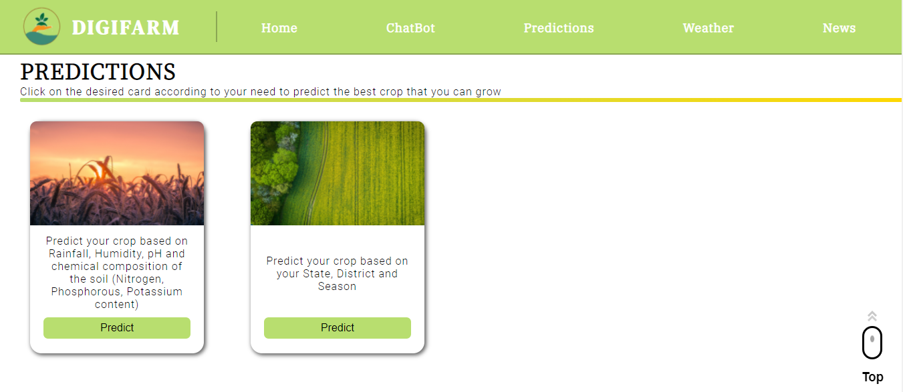

*Figure 3: Predictions Section (Different methods for predicting the crop)*

1. By entering pH, rainfall, humidity, temperature, and composition of the soil (nitrogen, phosphorus, and potassium content). Users can predict their crop by entering the values for above mentioned fields as shown in figure 4.

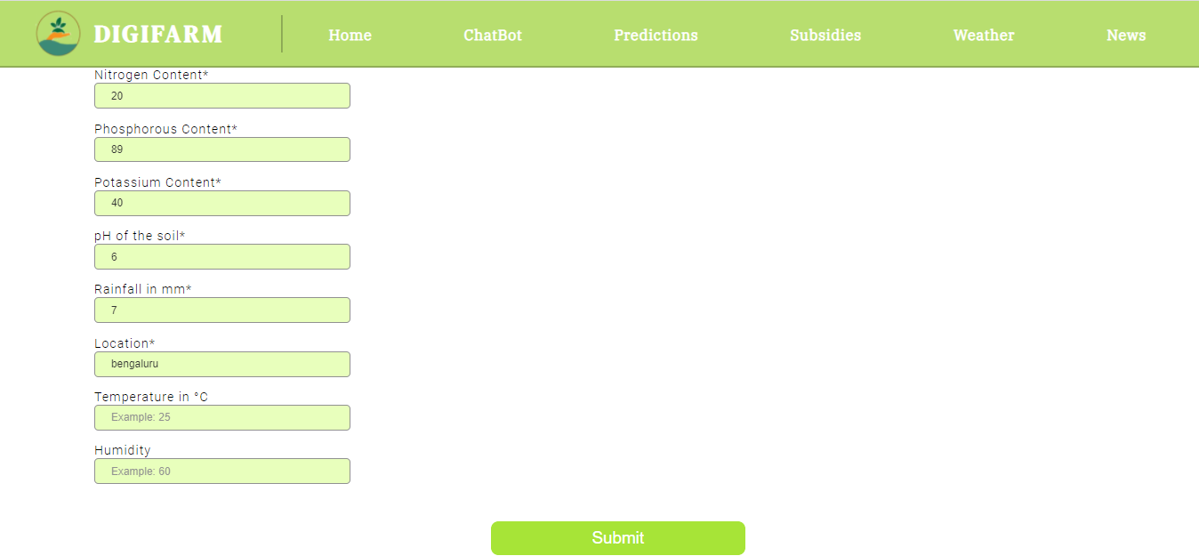

*Figure 4(a): Input fields for approach 1*

For example - When we enter the nitrogen content as 20, phosphorus content as 89, potassium content as 40, pH as 6, rainfall as 700, location as Bengaluru (ref figure 4(a)), we get the crop prediction of Coconut as shown in figure 4(b).

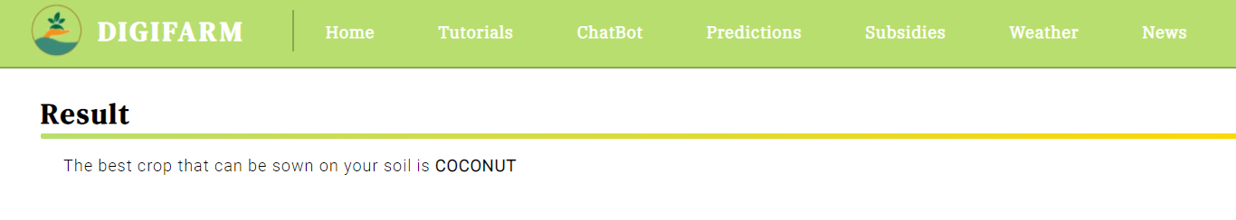

*Figure 4(b): The Result based on the information entered.*

Based on the values entered by the users our Machine Learning Model will predict the best crop that can be sown on their land.

Machine Learning Model:

We have trained the ML Model using the dataset as shown in the figure 6.

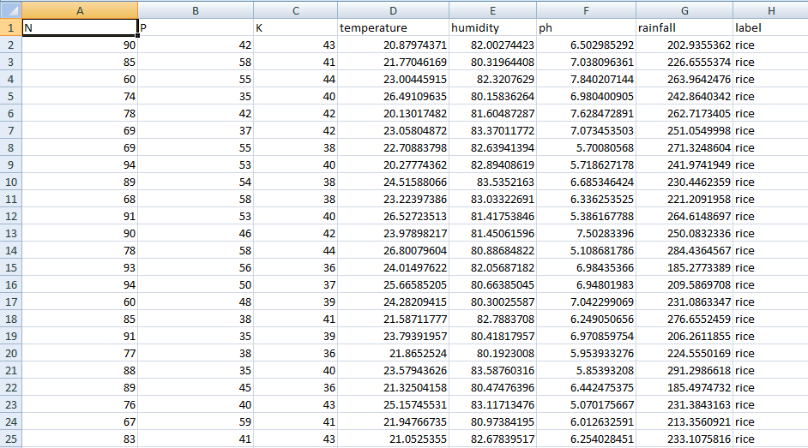

*Figure 6: DataSet used to train Machine Learning Model*

For training and deploying the ML model we have used IBM Cloud Services which includes ML and AutoAI services. Since it is deployed in a cloud we are using the ML Model through API. The classification type of the ML Model is Multiclass Classification.

1. Another option for the users is to predict crops by mentioning their state, district, and season as shown in figure 5.

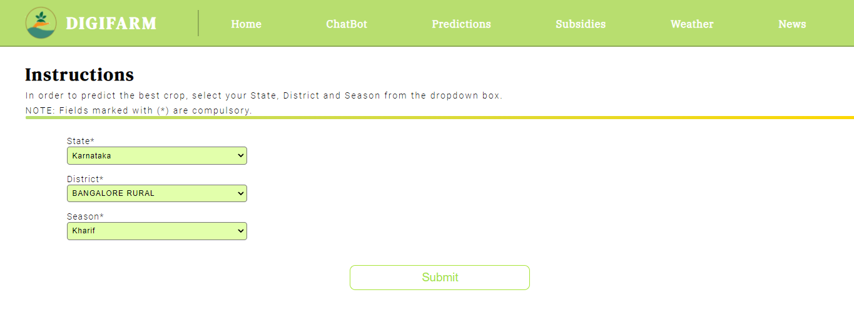

*Figure 5(a): Input fields for approach 2*

For example - When we enter the state as Karnataka, district as Bengaluru Rural, season as kharif (ref figure 5(a)), we get the crop prediction of ONION, DRY GINGER, RAGI, BAJRA, MAIZE, RICE, GRAM and many more as shown in figure 5(b).

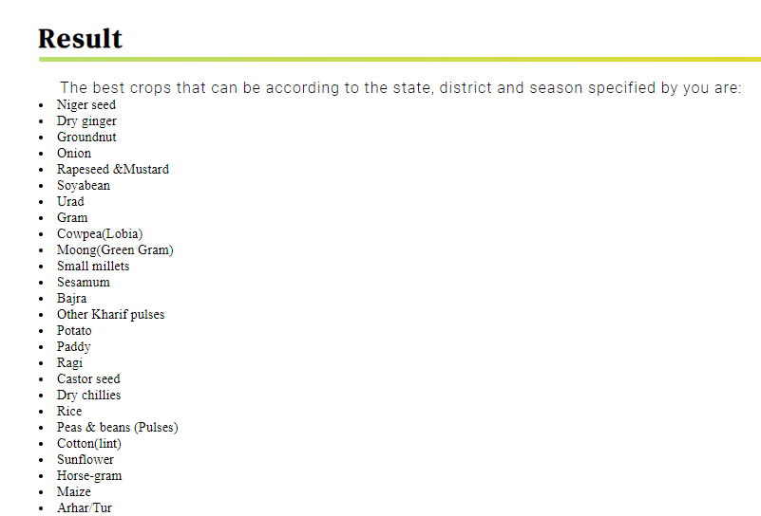

*Figure 5(b): Sample result from the second approach to Crop Prediction*

1. **Weather Section**: - The weather section informs the user about the current weather in their city as they enter their location.

For example - On entering the location as Bengaluru in the input field as shown in the figure 6(a), it will tell the current weather of the place including current temperature and humidity as shown in figure 6(b).

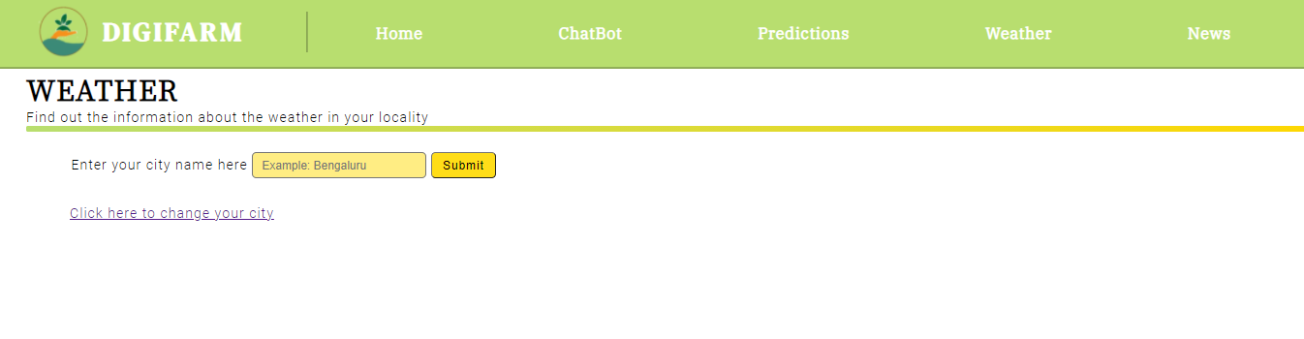

*Figure 6(a): Weather section*

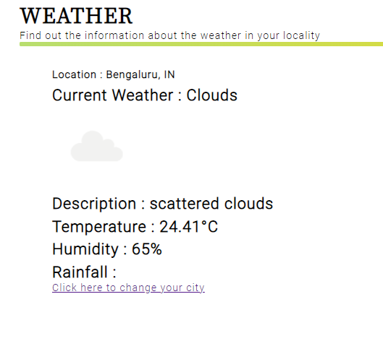

*Figure 6(b): Weather section result*

Entering the name of a city incorrectly, such as **Bengalir**, will result in an error         message asking them to re-enter the city’s name as shown in figure 6(c).

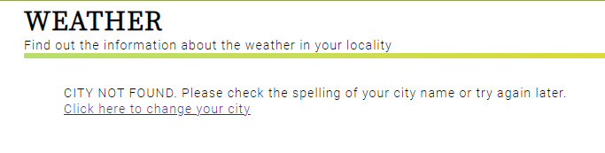

*Figure 6(c)*

In order to show the current weather for the users we have made use of OpenWeather API (Application Programe Interface) (<https://openweathermap.org/api>).

**4. News Section**: - The news section will tell the users about the latest news updates about agriculture.

In the news section of the website, we have used RSS (Really Simple Syndication) news feed from “The Hindu Agri-Business” section and for styling the feed we have taken the help from<http://www.rssfeedwidget.com/> website. This will enable the farmer to keep himself/herself with the latest news on one platform.

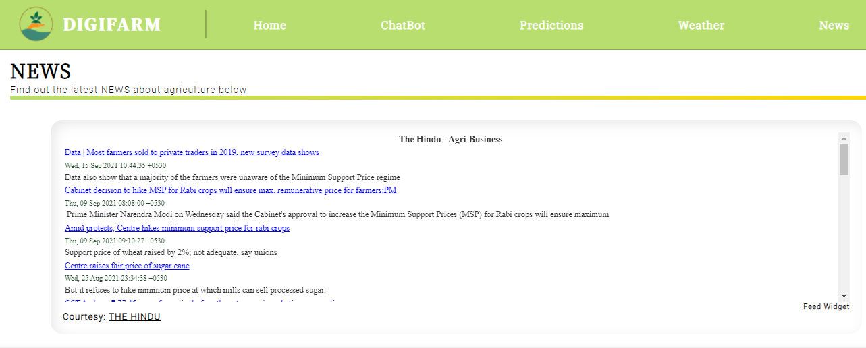

*Figure 7: News section*



The idea is to build a platform which solves all the queries of the farmers holistically and comprehensively.